Question one:

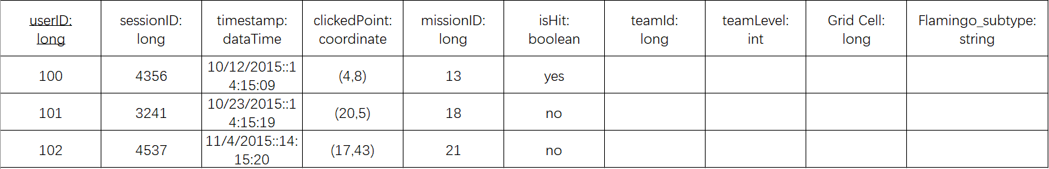

Explanation:

UserID which is underlined is the primary key as the principal means of identifying tuples within a relation.

Each data types are specified.

Since users are within a team, team ID and team level are included in the clicks data.

Grid cell and flamingo subtype specify another attribute of data related to user click.